17.114: Equation(17.21) becomes 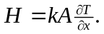
- Denoting the points as 1 and 2, 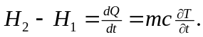 Solving for 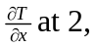
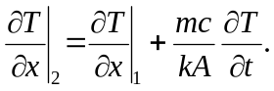
The mass m is 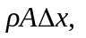so the factor multiplying 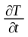in the above expression is 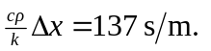Then,
